**Sprint 2 Plan**

Product Name: Toss Time

Team Name: Sinked Inc.

Completion Date: Nov. 2nd, 2021

**Goal**:

For this sprint, we want to implement a working database which can store data such as coordinates, or classes such as table profiles. We also want to establish some basic UI design for our application.

**Task Listing**

“As a dye player, I want an app that shows nearby dye games on a map, so I can play more.”

Tasks A1-4: Completed during Sprint 1

Task A5: Be able to put a marker on the map ( 4 hours )

“As a dye player, I want to see if a house has good house rules so that I would enjoy playing there.”

Task B1: Install the current version of the project from Github ( 2 hours )

Task B2: Basic database implementation ( 10 hours )

Task B2a: Storing coordinates / numbers ( 4 hours )

Task B2b: Storing markers / table profiles (SQLite) ( 6 hours )

Task B3: Look into UI for iOS Apps ( 10 hours )

Task B3a: Set up basic UI for Tables on a map ( 5 hours )

Task B3b: Look into adding images to UI ( 5 hours )

“As a dye player, I want to see other players' stats and show off my own so that I can find players who are at my skill level.”

Task C1: Add some class into the database for tournaments ( 3 hours )

Total time=: ( 29 hours )

**Team Roles & Initial Task Assignments**

Cole Hennig - Product Owner - Tasks B1, B3

Anton Kozintsev - Scrum Master - Tasks A5, B1, B3

Kenny Blum - Team Member - Tasks B1, B2, C1

Ryan Ahrari - Team Member - Tasks B1, B2, C1

Steve Beurard - Team Member - Tasks B1, B2, C1

**Sprint 2 Initial Burn-Up Chart**

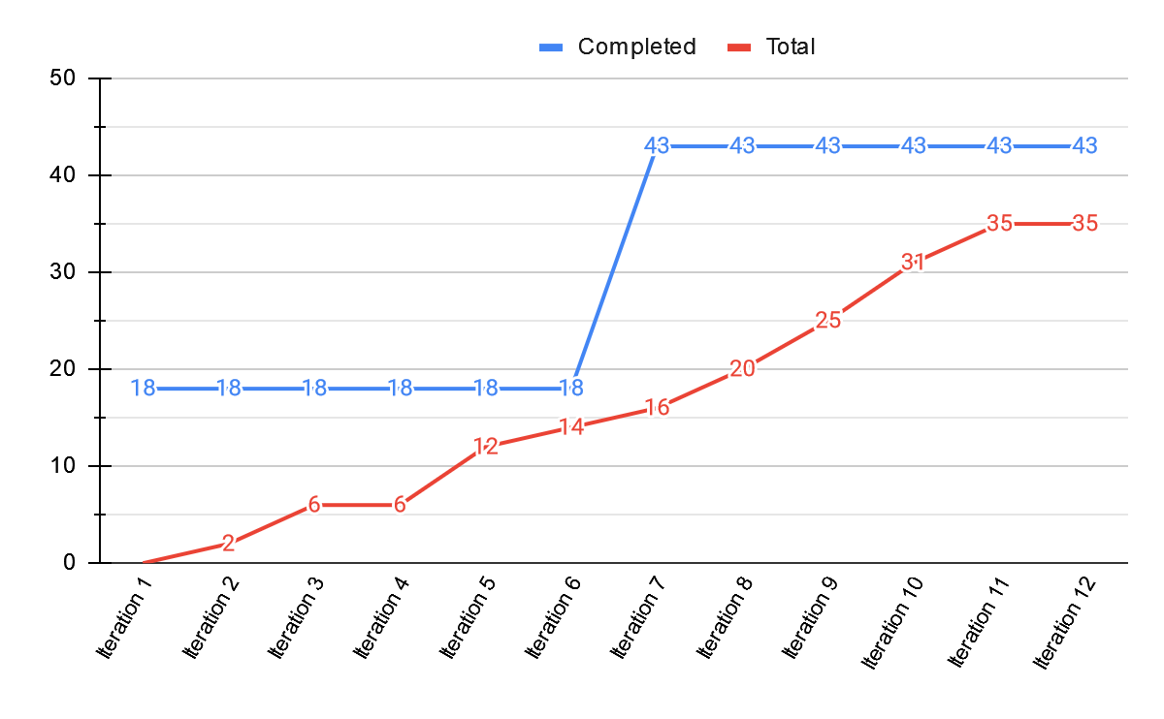

**Initial Scrum Board**

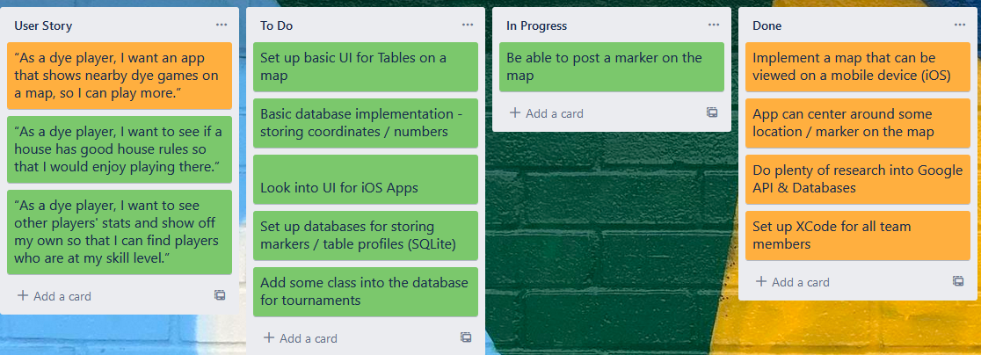

**Scrum Times**: Monday / Wednesday / Friday @ 2:30PM